

Th e

virtual

**ID EN TITY**"**& W**You**ELLBEINGONSOCIA**"**LM ED IA**

**PREPARED BY**

**MASON GORELICK**

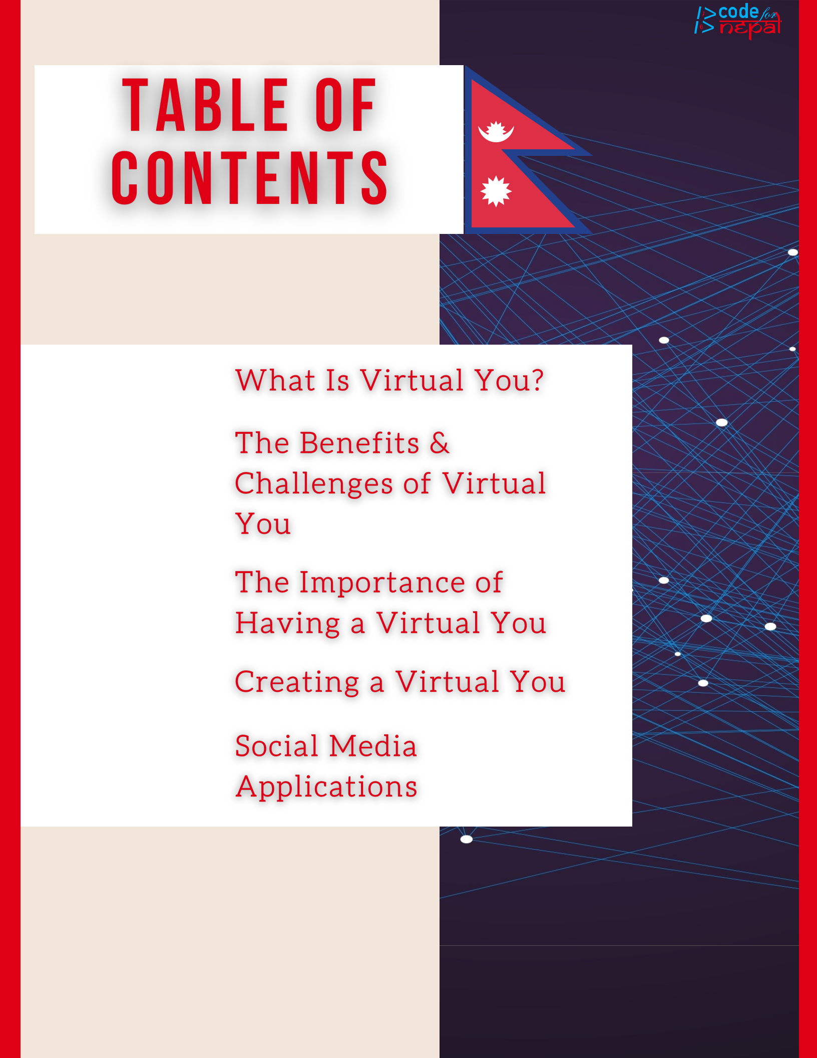

**PAGE 1....**

**PAGE 2....**

**PAGE 3....**

**PAGE 4....**

**PAGE 6....**

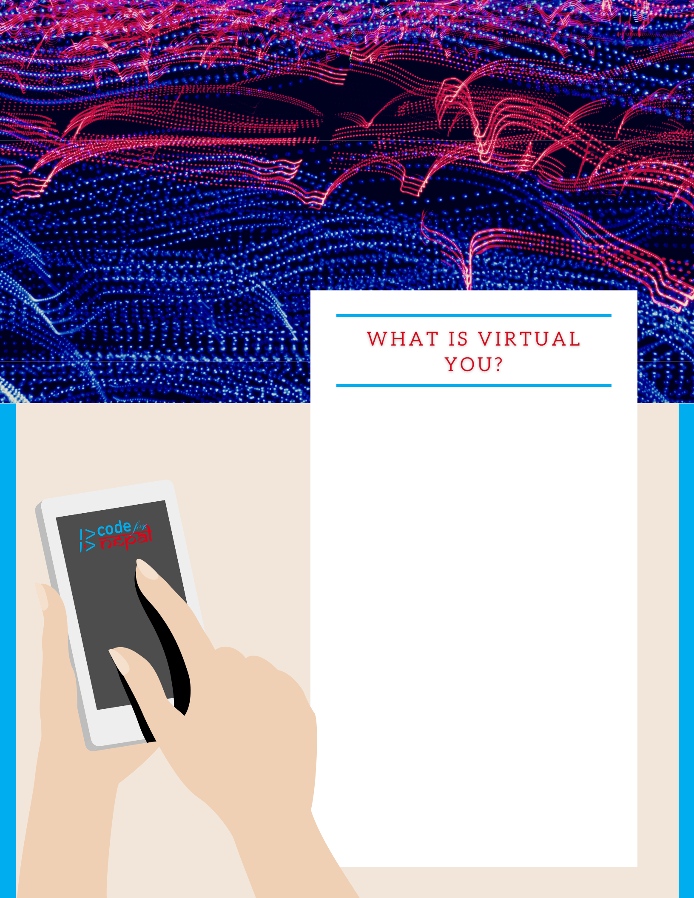

Whenever you go online, your online

presence represents a virtualized you. To be

more specific, a virtualized you is a profile

that you create with your name and/or

picture in it on any online platform. This

profile gives you a voice. This voice is you, a

virtualized you. Your identity online is just a

virtualized you.

There are many platforms that you may

choose to view online on your web or mobile

device. To find an application online, simply

go to your search engine, look at the top of

the screen for the search bar, then simply

click it with your cursor(The arrow on

your screen) or press it with your finger if

you have touch screen technology. Once

activated, you can look up any application

that you want!

Once you are on a website, your presence

there would be considered the virtualized

version of you!

**Page 1**

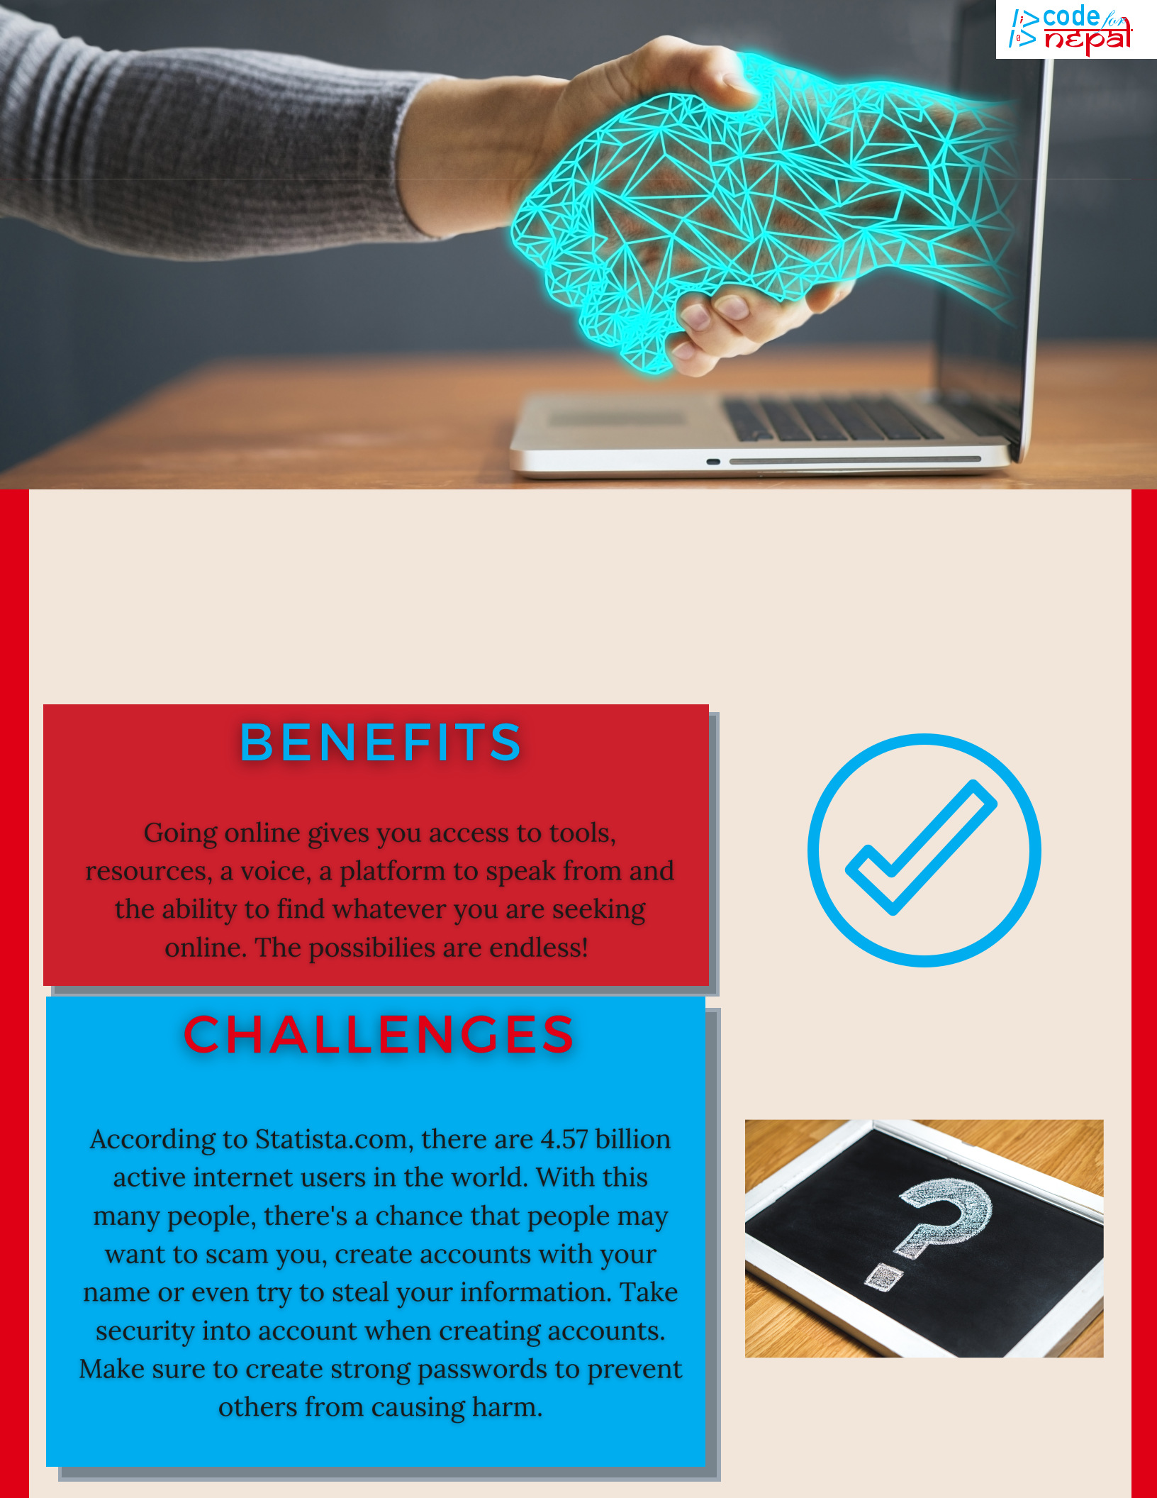

**The Benefits & Cha llenges of v irtua l you.**

**Page 2**

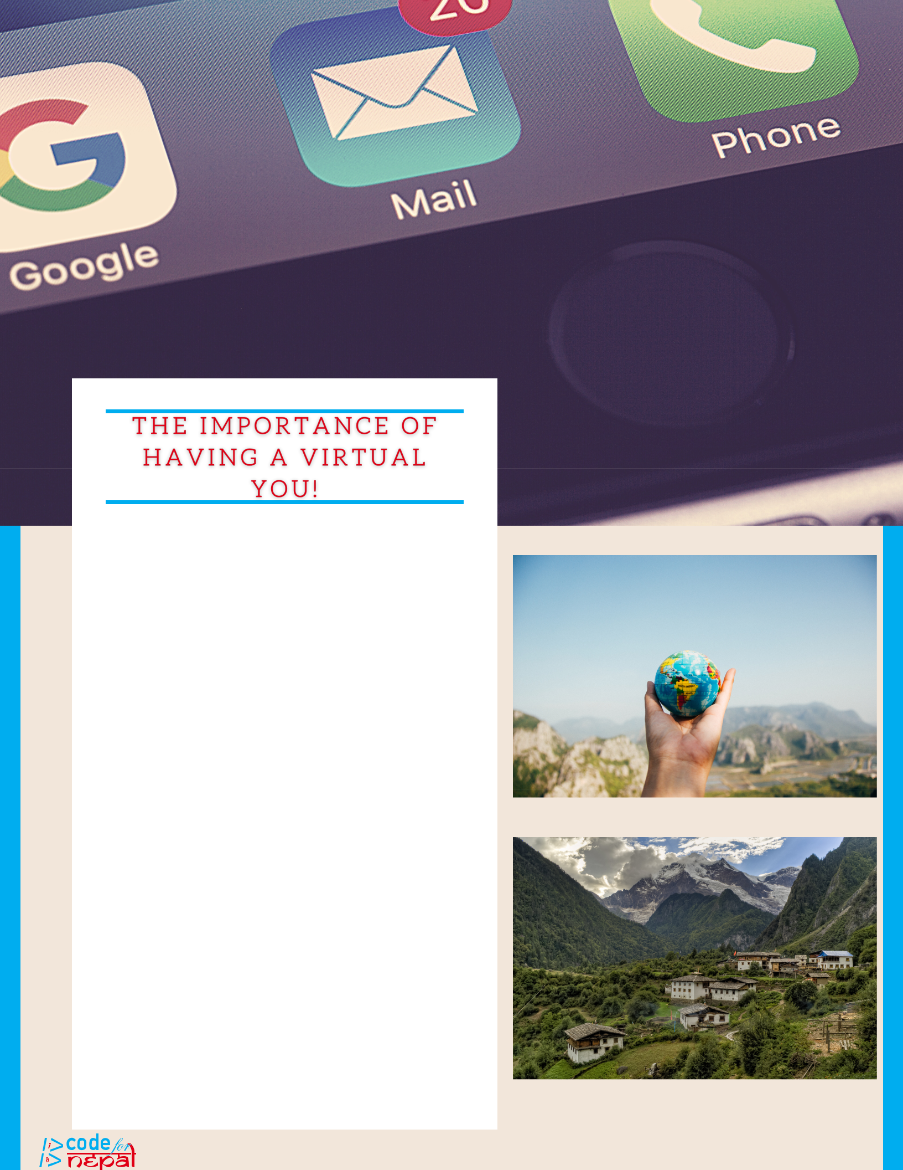

It's important to realize that having a virtual you is just as important as having a physical you nowadays. There are plenty of tools and resources that virtual you can receive online such as learning materials, multimedia content and access to job listings. Anything that you can think of can likely be found on the internet.

Not only do you have a plethora of tools and resources, but virtual you is a voice. Anyone from anywhere in the world can hear your voice and listen to what you have to say. This voice can change the world... starting with virtual you. Give yourself a platform to speak from online.

The world is becoming a global village full of knowledge and information at the tap of a button. Be apart of this village and use the power of the internet for good.

**Page 3**

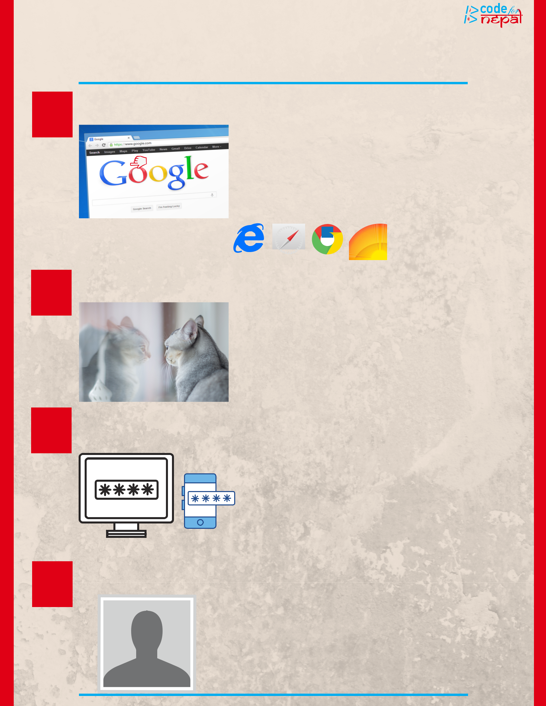

|  |  |  |  |
| --- | --- | --- | --- |
|  | crea tin g a virtua l you | ! |  |
| I . | **RESEARCH** | |  |
|  |  |  |

What is it that you are looking for online? It's important to research different online applications to find the right fit for you! First, go to your web browser and find the search engine bar at the top of your screen. Click or tap this search engine bar and type in whatever application you wish to view. Once you click search, the website should be there for you to view and research.

Web Browsing Applications:

I I .

III.

**REFLECT**

**FOCUS ON**

**SECURITY**

Make sure that you are comfortable with having your virtual-self attached to the application of your choosing. Will this online experience hurt or help your identity. By acknowledging the pros and cons of having your identity online, you will be more comfortable creating an account!

Are you able to protect your virtual-self? There are some bad people who want to steal your identity, so it's important to protect your accounts! When you create an online account, you will be asked to create a username and password for your profile. This information is valuable and show not be given to anyone other than yourself. By creating a strong password, you'll be more secure online.

I V .

**YOUR IMAGE**

When creating an account with your name on it, understand that anyone in the world can look your name up in the search engine. This means that your family, friends, teachers and even future employers can view the profiles you create. These profiles may not physically be you, but because they are attached to your information, they will represent you. Represent your virtual-self in the same way that you would want people to view your physical-self.

**Page 4**

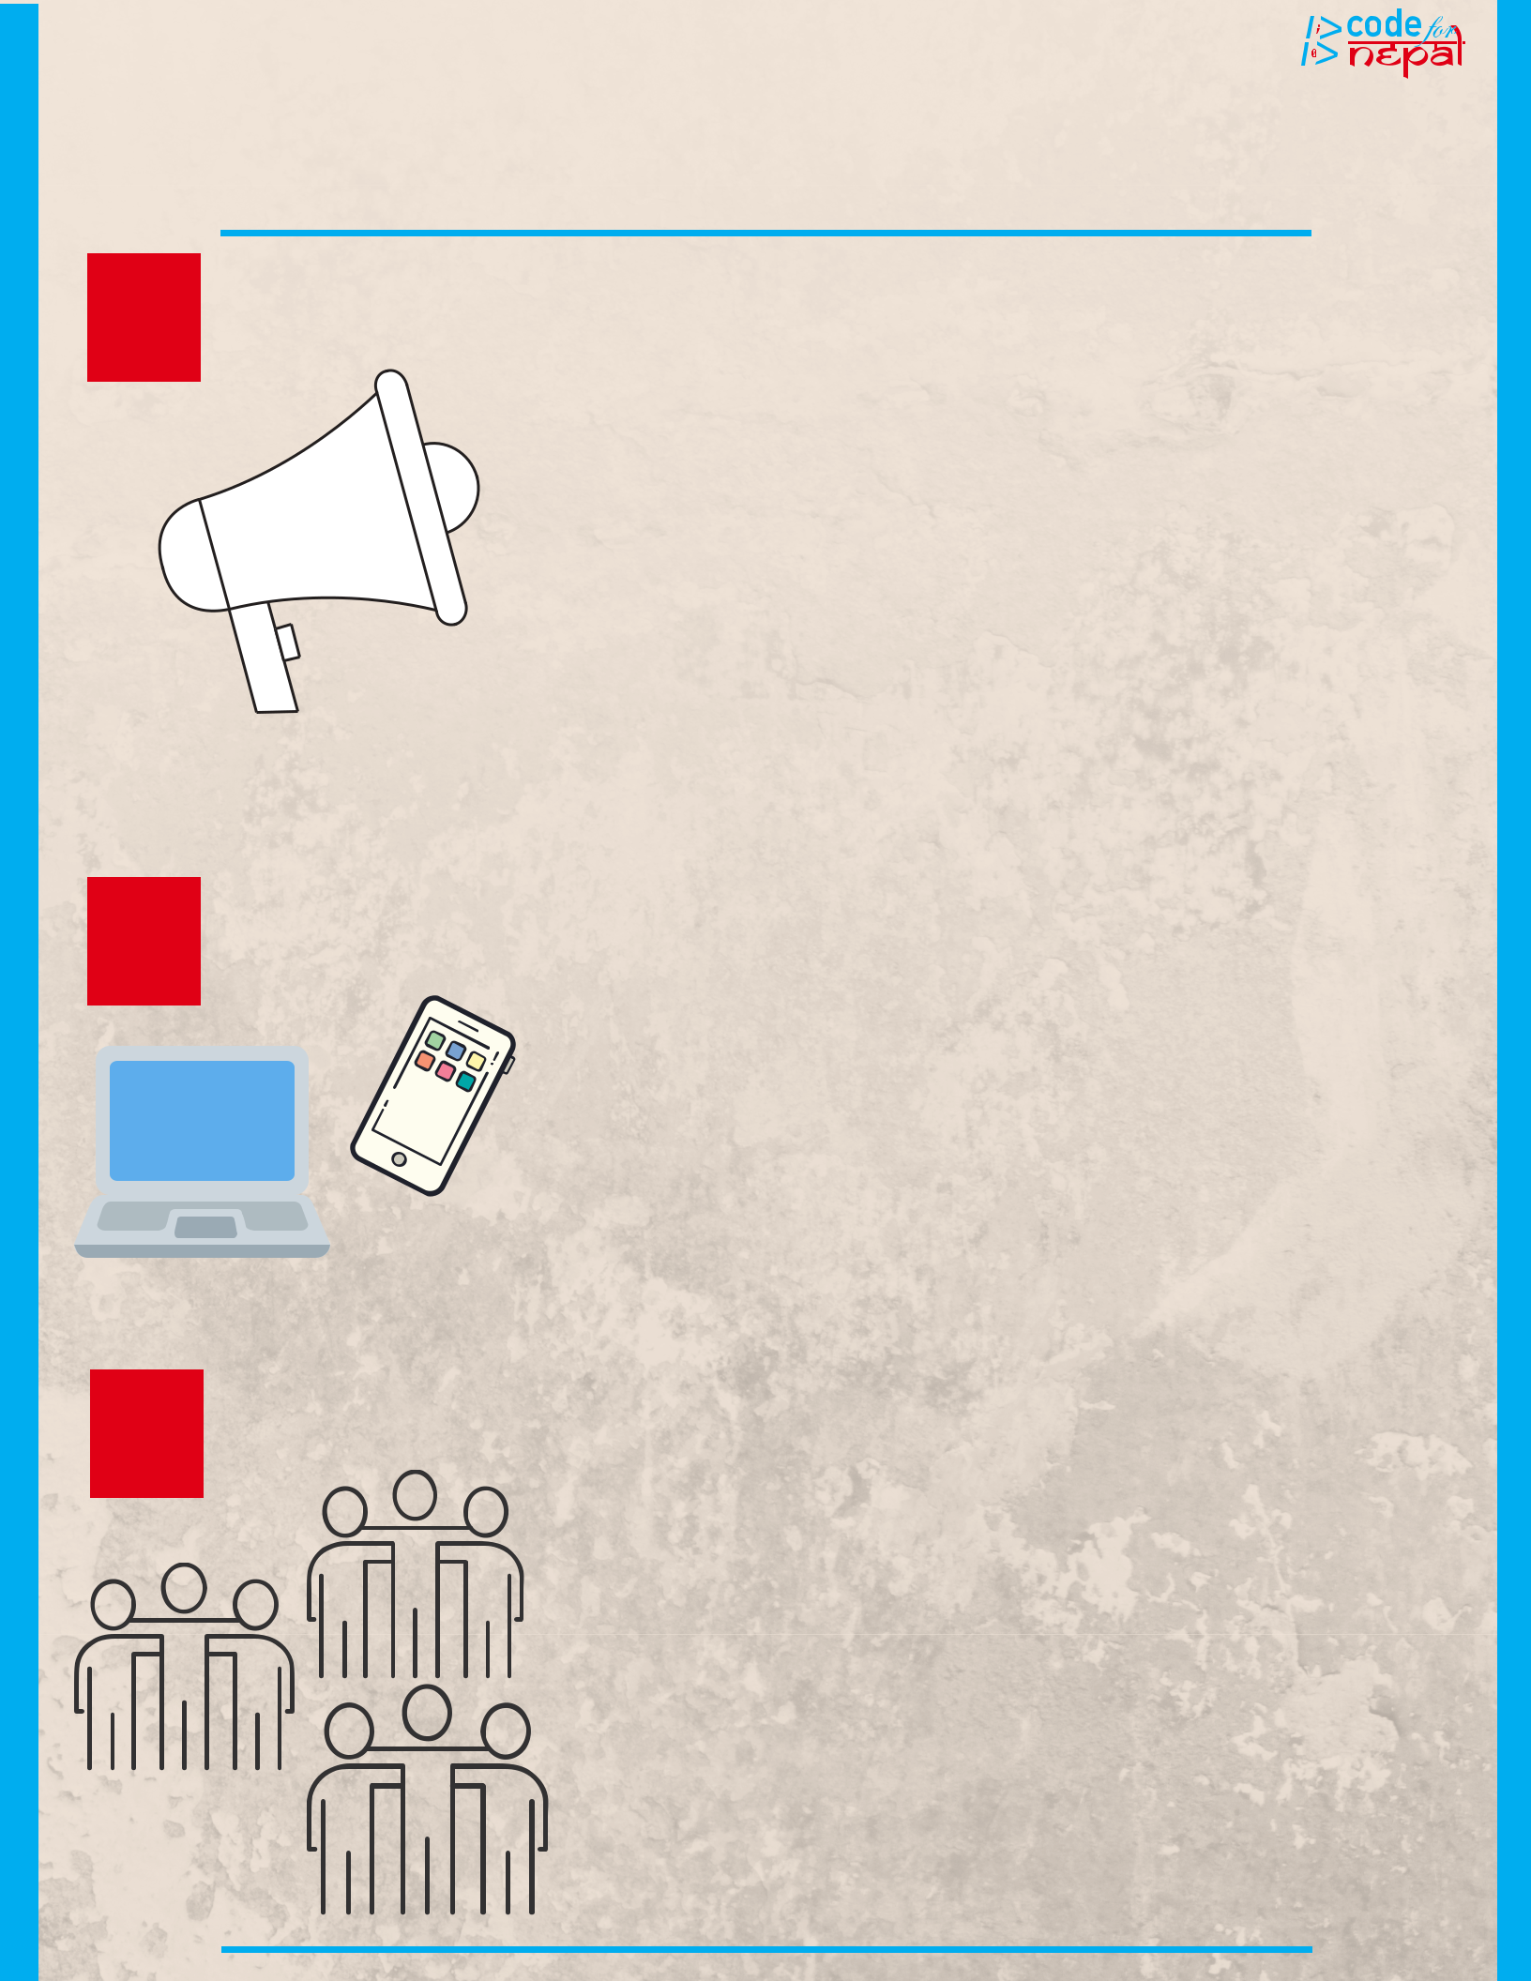

crea tin g a virtua l you !

|  |  |  |  |  |
| --- | --- | --- | --- | --- |
| V . | **YOUR** | **VOICE** | When you create an online account with your name |  |
|  |  |  |
|  |  | on it, you then have the power to communicate |  |
|  |  |  | online as your virtual-self. This communication |  |
|  |  |  | online would be considered your "online voice". |  |
|  |  |  | How will you use your voice? Really think about |  |
|  |  |  | this as your online voice reflects your physical |  |
|  |  |  | voice. Don't say anything that you wouldn't say in |  |
|  |  |  | person. Depending on what application you used to |  |
|  |  |  | create your profile, there are different types of |  |
|  |  |  | communicating methods that can be used. Some |  |
|  |  |  | applications focus on pictures and videos such as |  |
|  |  |  | Instagram, whereas other applications can focus |  |
|  |  |  | more on words such as Twitter. |  |

V I .

VII.

**EXPLORE**

**EXPERIEMENT**

As you use the internet more, you will learn and grow. Explore the internet, find what you are looking for and don't be scared to take risks. The internet is huge and made up of people from every part of the globe. Use this resource and learn from your experiences to accomplish whatever you can dream of.

Don't be scared to create more than one "virtual you"! Many applications online focus on different things, so don't be scared in changing your virtual self in the niche of your choosing. There are many applications online to choose from and each of these applications tend to focus on a particular niche. Are you online to find information, be entertained, share and view photos, etc.? Check out multiple online applications and grow accustomed to the community. This process of experimenting will help you better understand different online applications; ultimately improving your digital literacy.

**Page 5**

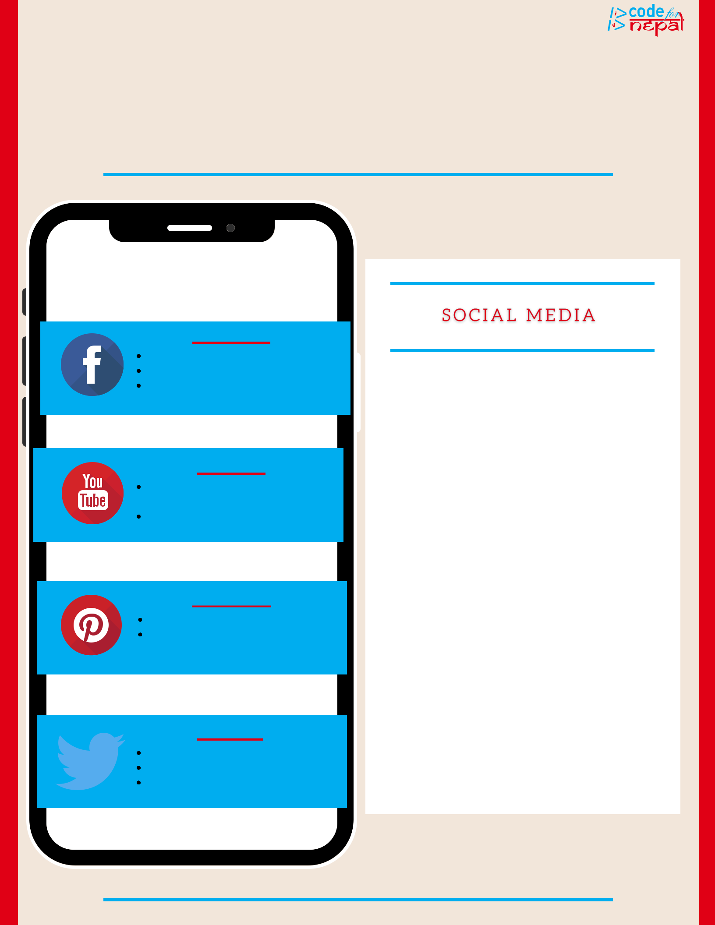

Socia l m ed ia a pplica tion s

Fa ceb ook

Sh a re/M A K E CON N ECTION S

SHOP

STAY UPDATED ON CURRENT

EVEN TS

Youtub e

CREA TE/VIEW visua l

CONTENT

ed uca te or en terta in

yourself

Pin terest

Fin d a n d sh a re id ea s

prom ote b usin ess ven tures

Tw itter

Resea rch

crea te con n ection s

sta y upd a ted on curren t

even ts

Social Media consists of online applications in which users can socialize with other users online.

To create a social media account, simply look up a social media application in your search bar. This will take you to the social media application in which you will have to create a username and a password. Once you have accomplished this, you will be able to look up people to "follow" on these applications.

As you can see from the example applications on the phone, there are many social media applications to choose from. All of these applications have different things for a user to view/use.

**Page 6**